Cleaning Instructions for Hardened Drop Cable Connectors and Adapters
1.0 PURPOSE

1.1 The purpose of this document is to provide step by step instructions for cleaning the Hardened Drop Fiber Terminals and Connectors with an SC/APC polish.

2.0 MATERIALS/TOOLS

2.1 5.5mm Allen wrench

2.2 Suggested Visual Scopes: EXFO FIP-435B and FIPT-400-OTAP-APC or VIAVI Probe and Tip FBPP5000I and FBPTCODL
2.3 Alcohol Wipes

2.4 Suggested cleaning stick: AFL One-Click® cleaner P/N 8500-05-0001MZ or equivalent


WARNING: Do not point fiber connectors towards eyes if they may be carrying laser light. Even though it may be invisible and painless, laser light can cause severe damage to the retina.


WARNING: Coiled cable ends have the potential to cause injury and/or damage the assembly components if suddenly released from coil. Always wear proper protective gear including eye protection when handling coiled cable assemblies and take care to release coiled flat drop cable carefully and slowly to avoid personal injury or damage.
3.0 CLEANING HARDENED CONNECTOR: Cables

3.1 Clean the connector body and dust cap with an alcohol wipe if it shows any signs of use to limit the possibility of additional debris contaminating the end face.

3.2 Remove the dust cap by turning the cap counterclockwise.
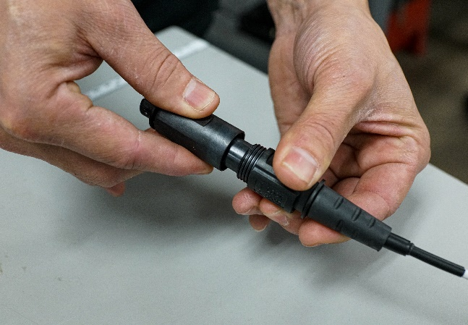

3.3 Inspect the end face of the connector by using a visual scope following the Manufacturer’s instructions.
Pass
Fail

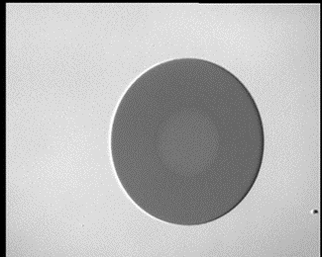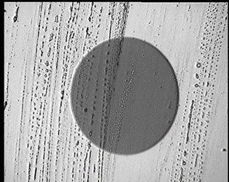

3.4 Insert the tip of the One-Click® cleaner into the connector and click. Repeat three times until the end face is thoroughly cleaned, then repeat step 3.3

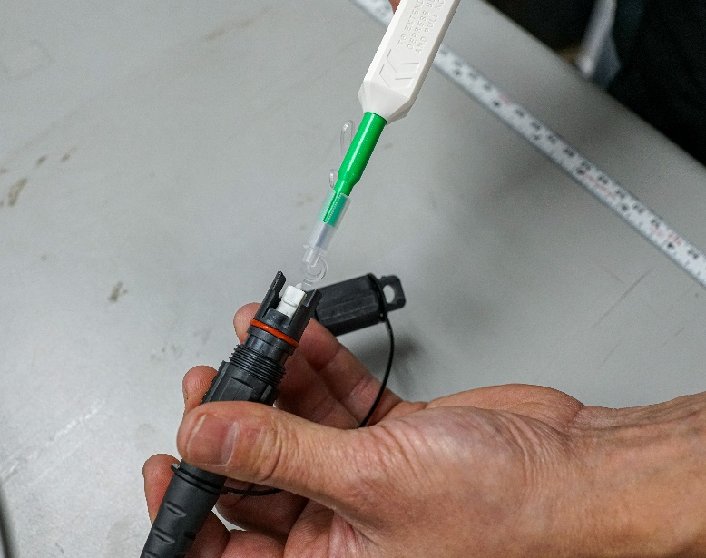

3.5 Replace the dust cap until the connector until is ready for use

4.0 CLEANING HARDENED ADAPTER: Terminal

4.1 Light Dirt and Dust: Clean the fiber Terminal thoroughly with clean water and dry towel paying special attention to remove any debris near the adapter dust cap and thoroughly dry with a towel.

4.2 Heavy Dirt and Mud: Spray the terminal with water and lightly use a brush if required, paying special attention to remove any debris near the adapter dust cap thoroughly dry with a towel.

4.3 Remove the dust cap by turning the cap counterclockwise using 5.5mm Allen wrench.

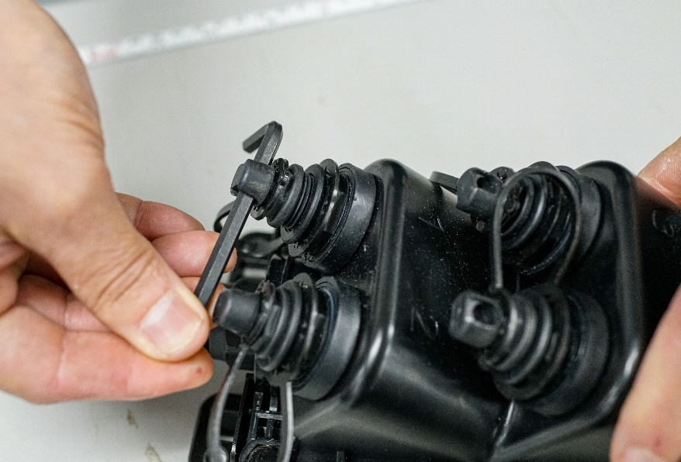

4.4 Inspect the end face of the connector by using a visual scope following the Manufacturer’s instructions., ref 3.3 image.

4.5 Insert the tip of the One-Click® cleaner into the OptiTap® adapter. Repeat three times until the end face is cleaned.

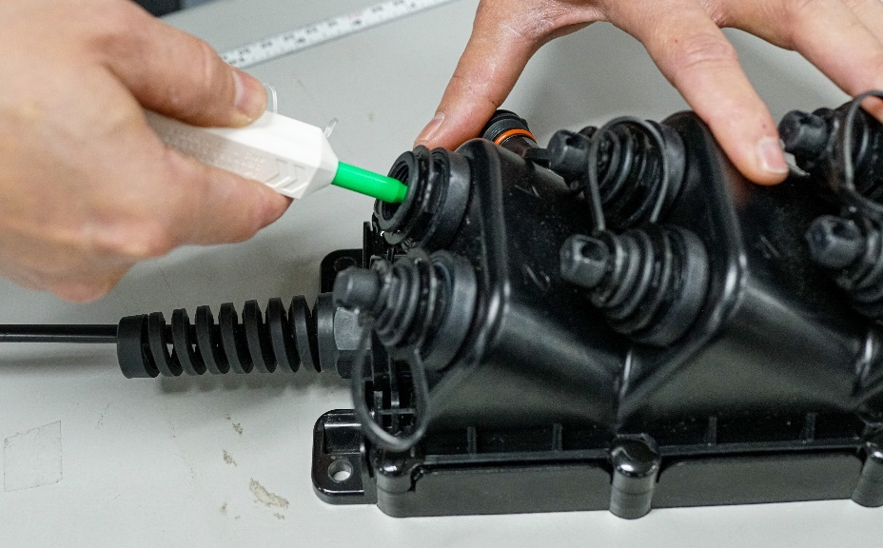

4.6 When the adapter is clean install the drop cable and tighten.

4.7 If the terminal will not be in use, replace the dust cap and securely tighten with the 5.5mm Allen wrench.

4.8 Repeat 4.1-4.7 with each adapter

