Assembly Instructions for NetSource OptiTap® Splice Terminal (OST)

15” (380mm) x 9.6” (245mm) X 5.1” (130mm)
1.0 Purpose

1.1 The purpose of this document is to provide installation instructions for OptiTap® Splice Terminals. The terminals can support cable OD from 10mm to 17.5mm.

2.0 Materials and Tools: Installation
- Fiber Splicing tools and equipment
- Accessory kit supplied with FTE
- Philips and flat head screwdriver
- Cutting knife and/or cable knife
- Fiber optic stripper (jacket)
- Fiber optic stripper for cable
- Cable marking tools
- Measuring tape
- Tie wraps

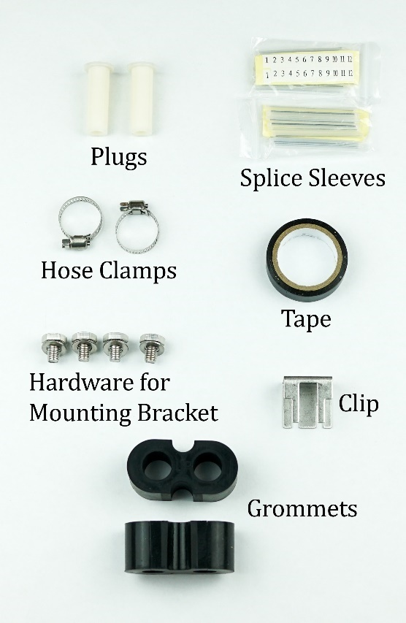
Image 2.1

2.1 Material and Tools: Cleaning
- Visual Scopes:
  - EXFO FIP-435B and FIPT-400-OTAP-APC or VIAVI Probe and Tip FBPP5000I and FBPTCODL
- Alcohol Wipes
- One-Click cleaner Senko part # SCK-SS-250

2.2 Material and Tools: Safety
- Work gloves
- Safety glasses

WARNING: Do not point fiber connectors towards eyes if they may be carrying laser light. Even though it may be invisible and painless, laser light can cause severe damage to the retina.
WARNING: Coiled cable ends have the potential to cause injury and/or damage the assembly components if suddenly released from coil. Always wear proper protective gear including eye protection when handling coiled cable assemblies and take care to release coiled flat drop cable carefully and slowly to avoid personal injury or damage.

3.0 Installing the Cable into the Enclosure

3.1 Loosen the 4 screws with the Allen wrench and use a flathead screwdriver to pry open the four hinges.

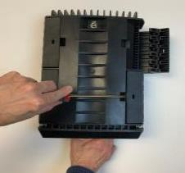

3.2 Use the Clip to prevent the lid from moving during installation.
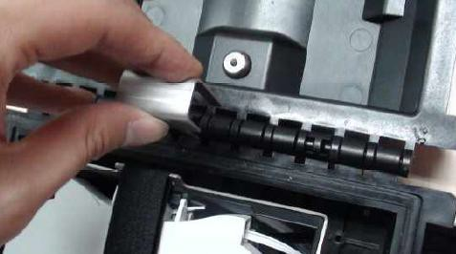

3.3 Using the Allen wrench, remove the hardware and sealing components from the bottom cable port.
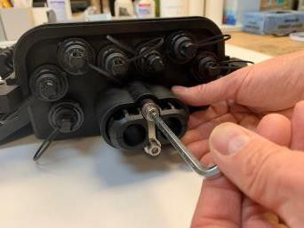

3.4 The enclosure comes with two different sized grommets. Select the correct grommet for your cable OD remove and set aside the metal compression plate and disassemble the gasket.
Small Grommet 10mm-12mm OD, Large Grommet 12.5mm-17.5mm
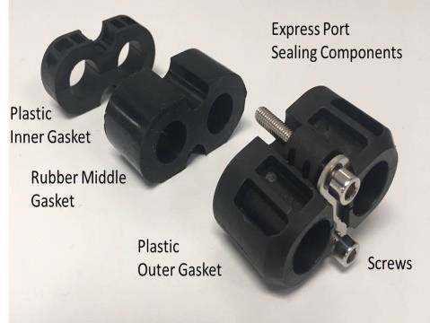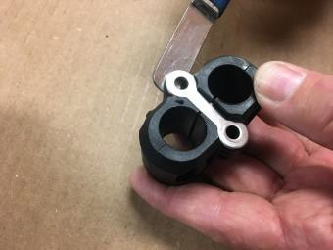

3.5 Split the grommet for the correct cable ID in half so the uncut cable can pass-thru.

3.6 Prep the cable.
- Strip back min of 6.5ft - 7ft of the outer sheath.
- Cut back the central strength member to 2.5” to 3.0”.

3.7 Install cable.
- Feed the prepped cable through the bottom port and secure the central strength member to the backplate.
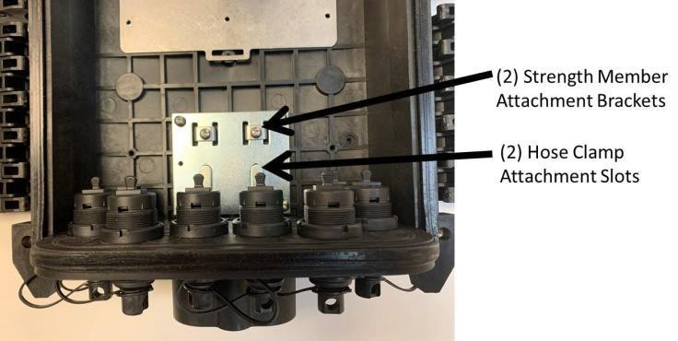
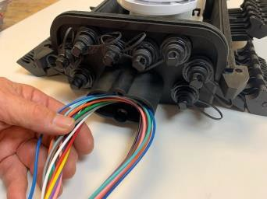
- Secure the outer sheath of the cable to the hose clamp provided and using screwdriver.
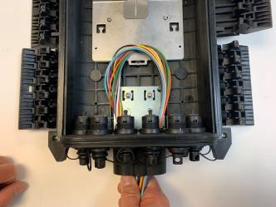
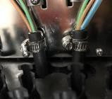

3.8 Assemble the inner grommet over the cable jacket.
- Push the grommet into the sealing gasket. Securing the compression plate with 5mm Allen wrench.
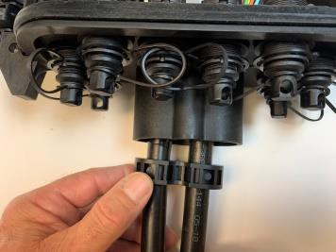

4.0 Splicing and Routing the Cables in the Terminals

4.1 Route the fiber buffer tube around the splice tray and under the hinged bracket using extra caution to confirm the fiber buffer tube is under the bracket. This will prevent possible pinching when the door closes. Tie down as needed.

4.2 Mark the fiber buffer tubes where the cable enters and exits the splice tray.

4.3 Strip back the outer jacket to expose the fiber using the marking on the jacket as a reference point.

4.4 Secure the buffer tubes to the splice tray with tie wraps (do not tie wrap to the exposed fiber).

4.5 Coil and route the fan out cable in the splice tray.

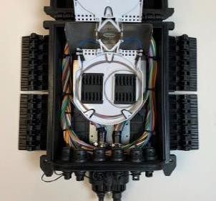

4.6 Perform splicing operations between the feed fiber and the pre-installed fanouts per manufacturers’ instructions.

4.7 Close the splice tray cover and secure with Velcro strap.
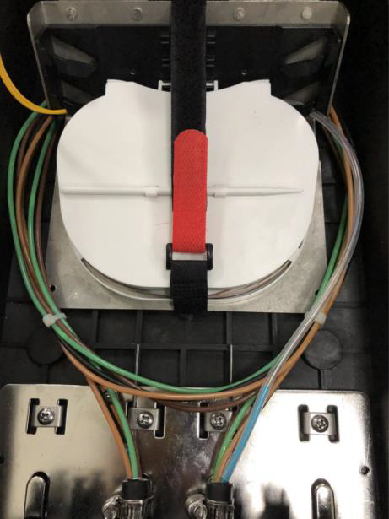

5.0 Closing the OST

5.1 Place the palm of one hand on the outside of the latch and place the other hand on the opposite side of the unit to steady the unit.
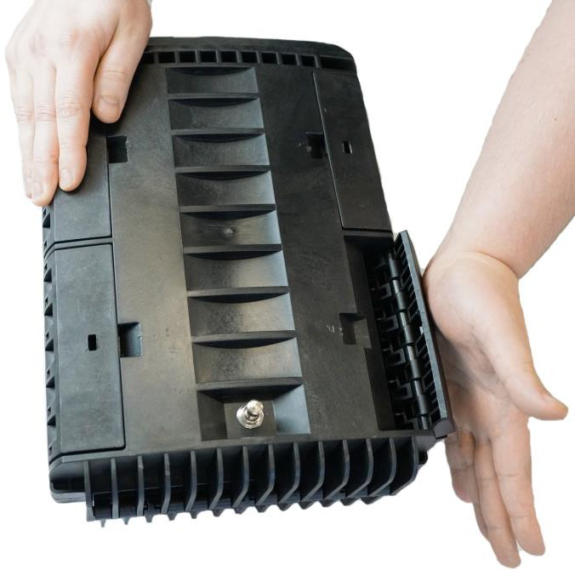

5.2 Push the latch toward the center of the OST until the latch snaps into place – repeat for each latch.

5.3 Use the Allen wrench to tighten all four screws.

6.0 Mounting the OST
- The OST comes with three different mounting options, Aerial Strand, Pole, and Wall/Pedestal Mount. The back of the OST has four threaded inserts for mounting all hardware and is included with the terminal.
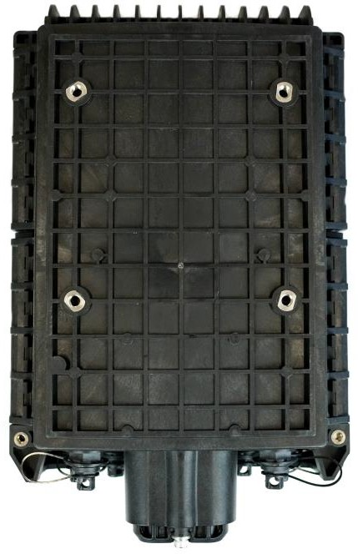

6.1 Aerial Strand Mount – Supports ¼” and 3/8”
- Attach the mounting brackets as shown.
- Hang the brackets over the strand and tighten the clamps.
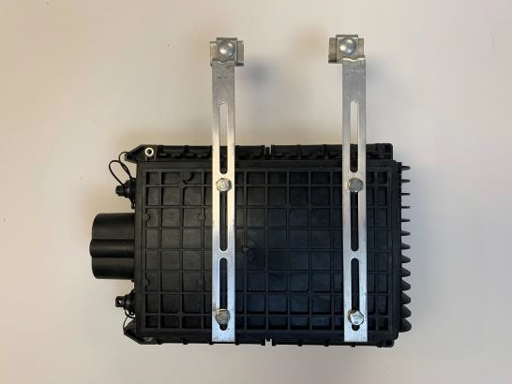

6.2 Pole mount with straps
- Attach the mounting brackets as shown.
- Route the straps through the brackets and secure.
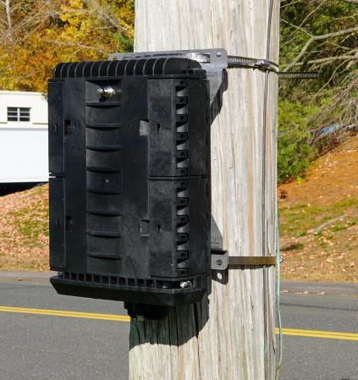

6.3 Pole mount with lag bolts
- Attach the mounting brackets as shown in the images.
- Using the bracket as a template, mark the pole and drill accordingly.

7.0 Cleaning Hardened Connector: Cables

7.1 Clean the connector body and dust cap with alcohol wipe if it shows any signs of use to limit the possibility of additional debris contaminating the end face.

7.2 Remove the dust cap by turning the cap counterclockwise.

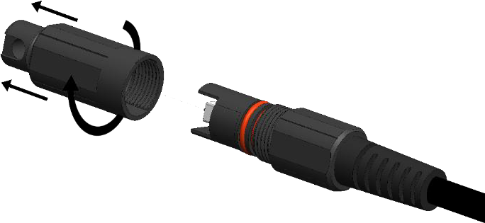

7.3 Inspect the end face of the connector by using a visual scope following the manufacturer’s instructions.

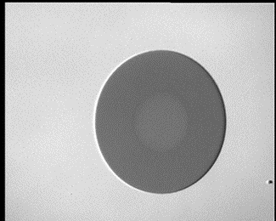
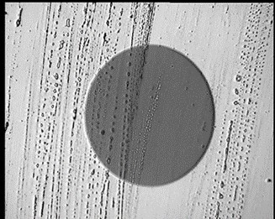
Pass
Fail

7.4 Insert the tip of the One-Click cleaner into the connector and click. Repeat three times until the end face is thoroughly cleaned. (Repeat step 7.3)
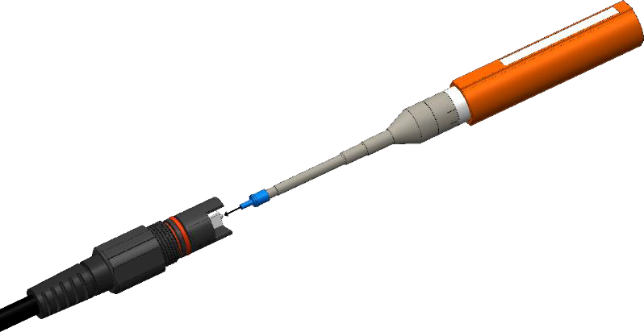
7.5 Replace the dust cap until the connector is ready for use.

8.0 Cleaning Hardened Adapter: Terminal

8.1 Light Dirt and Dust: Clean the fiber terminal thoroughly with clean water and dry towel paying special attention to remove any debris near the adapter dust cap thoroughly dry with towel.

8.2 Heavy Dirt and Mud: Spray the terminal with water and lightly use a brush, if required, paying special attention to remove any debris near the adapter dust cap thoroughly dry with a towel.

8.3 Remove the dust cap by turning the cap counterclockwise using a 5.5mm Allen wrench.
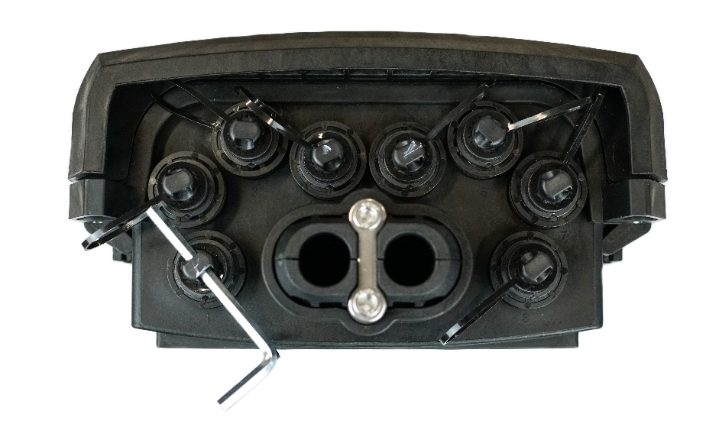

8.4 Inspect the end face of the connector by using a visual scope following the manufacturer’s instructions.

8.5 Insert the tip of the One-Click cleaner into the OptiTap adapter and click. Repeat three times until the end face is cleaned.

8.6 When the adapter is clean, install the drop cable and tighten.

8.7 If the terminal will not be in use, replace the dust cap and secure tightly with the 5.5mm Allen wrench.

8.8 Repeat 8.1-8.7 with each adapter.

